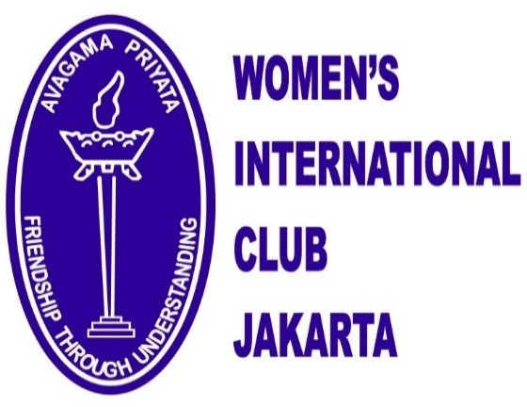
WCI 16th Biennial
International Conference 2020
Registration 14 June 2020
14 - 19 June 2020
Jakarta, INDONESIA
www.wciclubs.org www.wic-jakarta.or.id

Last Name | First Name | Middle Initial
Postal Address | City/State | Country | Zip/Postal Code
Email Address | Phone Number (Include Country/City Codes)
Club Affiliation (Name of Club) |  | WCI Executive  (√)  Committee or  (√) WCI Board
Club Office/Position Held
Name of Spouse/Guest (Mr., Mrs., Ms.)

CONFERENCE FEE AND PACKAGE PRICE
Registration Fee (for all attendees) | US$150 | Deadline: | No Refund after
Conference package: | US$775 | 2 March 2020 | 2 April 2020
Total | US$925
EARLY BIRD DISCOUNT |  | Early Bird deadline:
Registration Fee (for all attendees) | US$150 | 15 January 2020
Conference package: | US$675
TOTAL per person | US$825
NOTE:
The Conference Package includes all programs, excluding accommodations.
Hotel: Jakarta (14-19 June 2020) | DIRECT BOOKING | Refer to separate attachment

REFUND POLICY
1. No refund will be given for Early Bird for Conference Package.
2. No refund will be given for Registration Fee.
3. No full refunds will be given. Partial refunds ONLY on Conference Package will be given for cancellations received before 2 April 2020,
and may be available only after written notice is received AND subject to Women's International Club Jakarta's approval.
4. Any conference or remittance expense incurred in the processing of a refund on behalf of an attendee will be deducted from the refund.
5. No refund will be given for an individual event should an attendee choose not to attend an event or excursion.
6. No reimbursement will be given for alternative transportation arranged by the attendee.

REGISTRATION AND PAYMENT
By Email to:  wicwci.conf2020@gmail.com | Bank Name: CIMB NIAGA  Swift Code: BNIAIDJA  Account Number (USD): 800 162 9878 40  Account Name: WOMEN'S INTERNATIONAL CLUB JAKARTA
NOTE:  Please contact Mrs. Gina Alamsjah / Mrs. Anita Djajadiningrat / Mrs. Mina C dL - Northcott at the above email address for all queries. | NOTE:  All funds must be paid by all the attendees in US Dollars to the above account and All bank processing fees (sending and receiving) to be paid by the attendee and transfer slip to be emailed to wicwci.conf2020@gmail.com

HOTEL ACCOMMODATIONS - HOTEL INDONESIA KEMPINSKI, JAKARTA
1. Please make your hotel reservation directly with HOTEL INDONESIA KEMPINSKI - JAKARTA, JL. MH Thamrin No. 1, Jakarta 10310, Indonesia + 62 21 2358 3800 Email: eka.viora@kempinski.com (Hotel reservation form attached).
2. A block of rooms has been reserved for WCI Conference attendees to be booked before 29 May 2020.
3. The room rate is valid for reservations from 11- 22 June 2020 (3 days prior to & 3 days after 14-19 June 2020).

CONFERENCE RELEASE AND WAIVER OF LIABILITY
As a paying participant and registrant, I hereby acknowledge and agree to waive and release any and all claims against Welcome Clubs International Incorporated, its Board of Directors, Executive Committee and Women's International Club Jakarta, its Board of Directors and members for any and all loss, accident or injury, including transportation, sustained while I am attending and/or participating in the
Welcome Clubs International Incorporated's International Conference, 14 - 19 June 2020
Upon check-in at the hotel, you will be asked to sign confirming this Release and Waiver of Liability. Please note that your spouse/guest will also be asked to sign, confirming this Release and Waiver of Liability.
Signature(s): Attendee Spouse/Guest

REGISTRATION FORM SIGNATURE - REQUIRED
Submitted By: Date:

Please print name:
You will receive a confirmation receipt of your Registration Form and all payments by email.

CONFERENCE NAME TAG
List how you want your name to appear
Member: | Spouse/Guest:

ARRIVAL AND DEPARTURE INFORMATION
Arrival Date: Time: | Airline arriving in Jakarta - Indonesia: | Flight Number | Last connecting city
Departure Date: Time: | Airline departing from Jakarta: | Flight Number | Next connecting city

OTHER IMPORTANT INFORMATION
Please ensure you have appropriate Travel Insurance
Transport vehicles are not equipped to handle wheelchairs. If you require assistance, you are responsible for bringing someone with you who can help with your special needs. Please do not rely on Women's International Club Jakarta, Welcome Clubs International or any
attendee to assist with wheelchairs, walkers, or heavy luggage.
I have special dietary needs: Vegetarian Vegan.
My Spouse/Guest has special dietary needs: Vegetarian Vegan.
Allergies:
I am interested in sharing a hotel room: YES
If you register by 2 March 2020, we will email you the list of others interested in sharing rooms.

YOUR EMERGENCY CONTACT INFORMATION:
Name: | Telephone (include Country/Area codes):
City/Country: | Relationship:

POST CONFERENCE TRIP
POST CONFERENCE TRIPS FROM 19 JUNE 2020 ONWARDS
Are you going on the Post Conference Trip? | YES Trip 1 Trip 2 Trip 3 | NO
Is your spouse/guest also going? | YES Trip 1 Trip 2 Trip 3 | NO
Details of each trip are in the separate Post Conference Trip attachment
This trip is arranged through P.T. NUSA INA LEISURE INDONESIA and is independent of WCI Conference. Price is subject to change.
Welcome Clubs International and Women's International Club Jakarta assume no responsibility for this trip
For more information contact:
Mr. Yongky Adiyasa Mobile: +62 811 803 963
Office: +62 21 587 1155 / 587 1156
Fax : +62 21 587 2255
Email: info@inaleisure.co.id
(with cc to: wicwci.conf2020@gmail.com)

